

全自动牛仔装袋机
High speed pocket for jeans
（MB1002F-Br-311HN）

使用说明书
Instruction Manual

常州智谷机电科技有限公司

在使用本设备之前请先阅读本使用说明书.
2020.01
版本信息
请将本使用说明书放在便于查阅的地方保管
感谢购买IMB工业用缝纫机。
在使用此机器之前，请仔细阅读以下的说明，这样可以更好地帮到您了解此机器的相关操作。
这些说明是根据现行的条例明确阐述了正确的工作方法。
Thank you for purchasing this industrial sewing machine from IMB
Before using this automatic unit, please read the following instructions, which will help you to
understand how the machine operates.
These instructions illustrate the correct working methods to comply with current regulations.

在没有得到IMB授权许可的前提下，此说明书的任何部分是不可以被复制或者转录的。
说明书的内容可能被修改，而不需预先通知。
No part of this manual may be copied or transcribed without requesting prior authorization from IMB
The contents of this manual may be subject to change without advance notification.

我们将欣然接受各位提出的改进此说明书的任何建议和指示
We are happy to receive suggestions and/or indications on ways we could improve this manual.

本机介绍说明分为三部分，具体请参照《MB1002F-使用说明书》、《MB1002F-零件手册》、《MB1002F-触摸屏界面操作说明》。

ENGLISH

Content
ESSENTIAL INFORMATION............... ........ ...... ...... . ...................
SPECIFICATIONS............... ..... ...... ...... ... .............. ............
SAFETY PRECAUTIONS................. ...........................................
BUTTON DESCRIPTION................... .........................................
1. Button function description.............................. .................
2. Reset operation instructions.......................... ....................
2.1 Power on reset operation.......................... ....................
2.2 Emergency stop reset operation............. ...........................
OPERATING INSTRUCTIONS................................ ........................
1. Preparation before operation...................... .........................
2. Operation process description....................... .......................
2.1 Boot device..................................... ......................
2.2 Reset operation....................................... ................
2.3 Placement of fabric......................................... ..........
2.4 Sewing start..................................................... .....
2.5 Sewing end............................................. ...............
2.6 Shutdown..................................................... ........
2.7 Abnormal situation.................... ................................
CHANGEOVER OPERATION................................. .........................
1. Boot reset............................................. ...................
2. Replace XX................................................... .............
3. Adjust XX.......................................................... .......
4. Adjust the laser .................................... ......................
5. Edit pattern.............................................. ................
6. Testing......................................................... ..........
ELECTRICAL INSTRUCTIONS....................................... ................
1. Signal board.................................................... ..........
2. Electromagnetic iron plate........................... .....................
3. Expansion board electromagnetic valve...................... ................
TROUBLESHOOTING....................................... ......... ..............
REGULAR MAINTENANCE GUIDELINES........................... .....................
INTELLECTUAL PROPERTY STATEMENT................................ ...............

1、ESSENTIAL INFORMATION 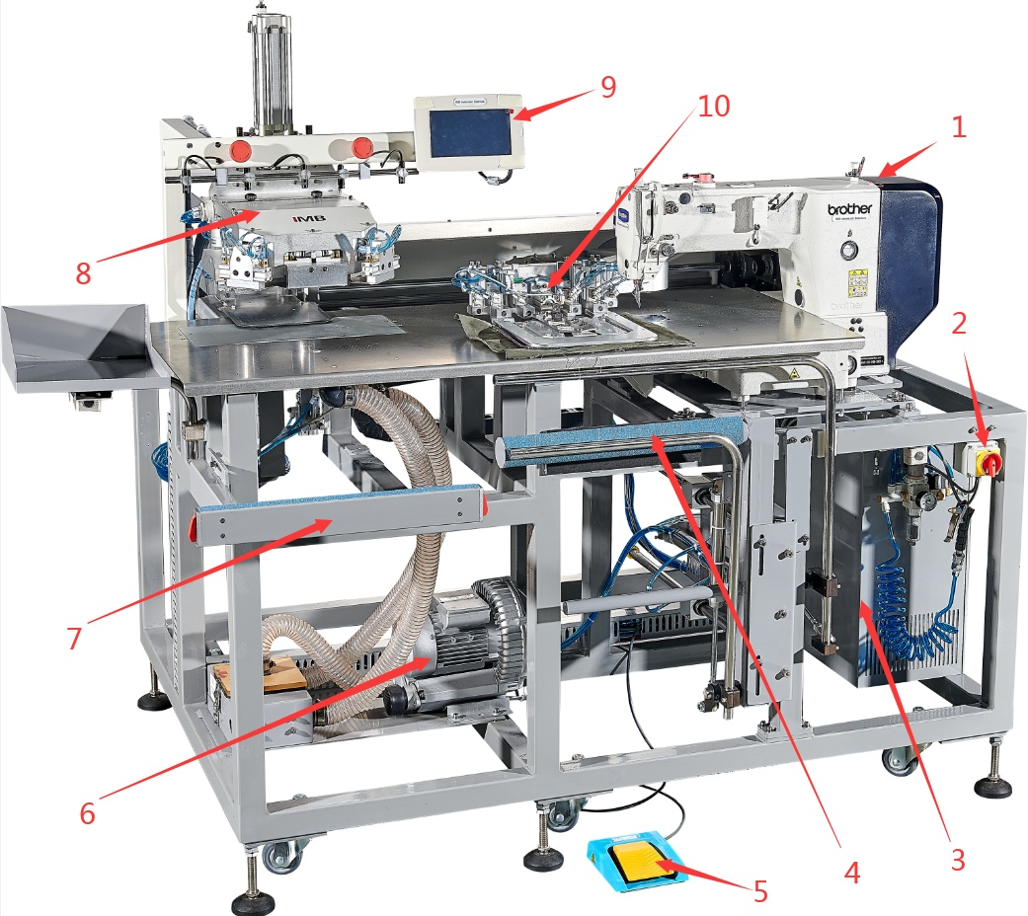

1：BAS-311HN Sewing head； 2：Power switch； 3：Control box； 4：Stacker； 5：Pedal； 6：Suction system; 7：Loader； 8：Folding group； 9：Touch screen； 10：Inner clamp

2、SPECIFICATIONS
MB1002F High speed pocket for jeans
1 | Machine head |  | brother-BAS-311HN
2 | Maximum speed/rpm |  | 2800
3 | Working voltage/V |  | 220
4 | Working pressure/Mpa |  | 0.5
5 | Motor |  | AC servo motor
6 | Stitch length/mm |  | 0.05--12.7
7 | Performance features |  | 8s/pc
8 | Size/mm |  | 1800L×1550W×1600H
9 | Weight/kg |  | 477
10 | Inner clamp size |  | S：90-125；  M：125-170；  L：170-220；
11 | Pocket shape | 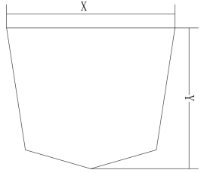 | Size | S：X:90-130；Y:90-130  M:X:130-185Y:130-170；  L：X:大于185；Y:大于170；
 |  | 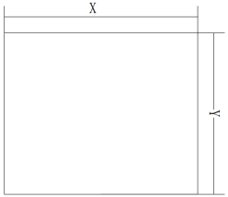
 |  | 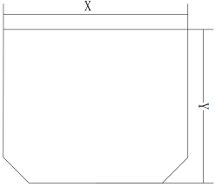
 |  | 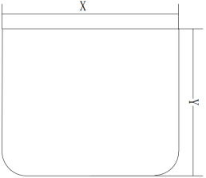

3. SAFETY PRECAUTIONS
Precautions for safe use of automata
 | 1. In order to prevent accidents caused by electric shock, please do not open the cover of the motor electrical box or touch the parts in the electrical box when the power is turned on.
 | 1. In order to prevent personal injury, please do not operate the machine with the belt guard, finger protector and other safety devices removed  2. In order to prevent personal accidents involving the machine, please keep fingers, hair and clothes away from the belt pulley, V-belt and motor during the operation of the sewing machine, and do not put objects on it.  3. In order to prevent personal injury, please do not put your finger near the needle when turning on the power or when the sewing machine is running.  4. In order to prevent personal injury, please do not put your fingers in the thread take-up rod cover when the sewing machine is running.  5. When the sewing machine is running, it turns at a high speed. In order to prevent injury to your hands, please never let your hands near the cloth cutter during operation. In addition, please turn off the power supply when changing the cable.  6. In order to prevent personal injury, please take care not to pinch your fingers when the sewing machine moves up and down or returns to its original position.  7. When the sewing machine is running, please do not cut off the power or air supply.  8. In order to prevent accidents caused by sudden start-up, when the preparatory work is finished and the sewing can be carried out, please remove the cloth guide.  9. In order to prevent accidents caused by electric shock, please do not operate the sewing machine when the power ground wire is removed.  10. In order to prevent accidents caused by electric shock and damage of electrical parts, please turn off the power switch before plugging in and out the power plug.  11. In order to prevent accidents caused by damage of electrical parts, please stop the operation and unplug the power plug for safety during thunder.  12. In order to prevent accidents caused by damage to electrical parts, condensation will occur when moving from cold places to warm places, etc., so please turn on the power after the water drops are completely dry.  13. Because this product is a precision machine, please pay full attention to the operation, do not splash water and oil on the machine, and do not let the machine drop to impact the machine.  14. This machine is a class A industrial machine. If this machine is used in the home environment, the phenomenon of radio interference may occur. At this time, please take appropriate measures to solve the problem of radio interference.  15. After the power switch is turned off when the stacker acts, the stacker bar acts, so please take care not to pinch fingers, etc.  16. After the power switch is turned off in the presser foot action, the presser foot action, so please pay attention not to pinch fingers, etc.  17. During the folding operation, please be careful not to let the air cylinder clamp the finger when putting the finger in the folding machine.

*WARNING：
√Improper operation of the machine may cause personal injury. Please read this instruction carefully and operate it correctly before operation.
√Please ventilate the machine before power on.
√It is strictly prohibited to open the electric cabinet or the internal parts of the touch screen when it is powered on.
√This machine needs to be used after being trained or under the guidance of a special person to ensure the personal safety of the user.

4、BUTTON DESCRIPTION
4.1. BUTTON FUNCTION DESCRIPTION
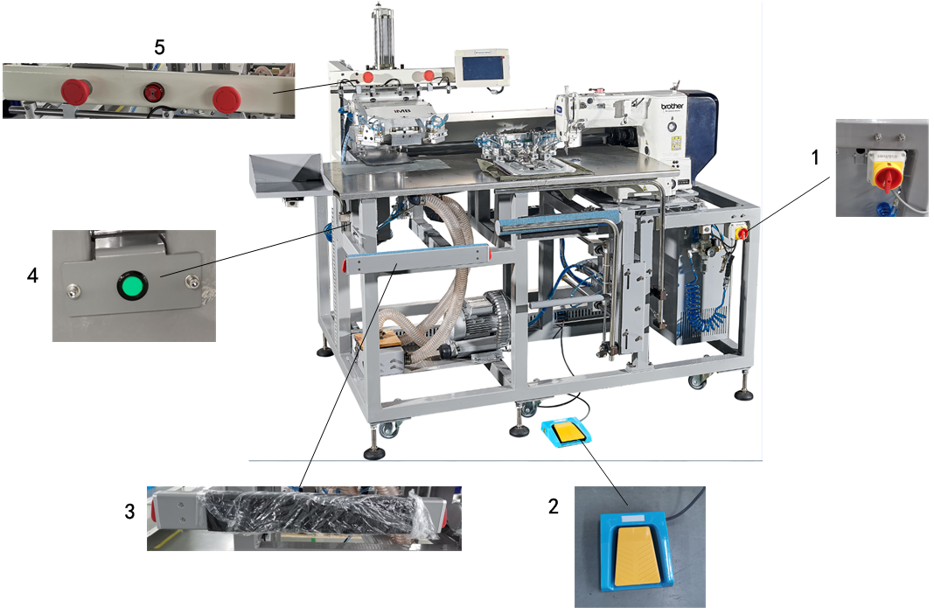
（1）：Power switch - turn the power switch 90 ° to on, and the equipment is powered on and ventilated.
（2）：Pedal: in foot mode, the center blade extends and retracts.
（3）：Start switch - press it and the machine will sew automatically.
（4）：Pad feeding switch --- pad feeding test. Press it to control the speed of pad feeding.
（5）：Emergency stop button (left) --- emergency stop of folding group.
Buzzer (medium) - fault alarm prompt.
Emergency stop button (right) --- sewing emergency stop.
（6）：Touch screen - see <mb1002f full automatic denim pocket setter - interface description for details>.

a：Main interface
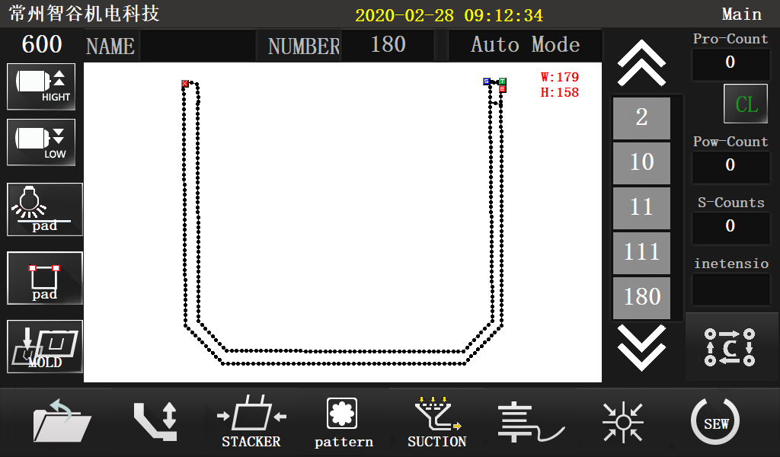
b：Sewing interface
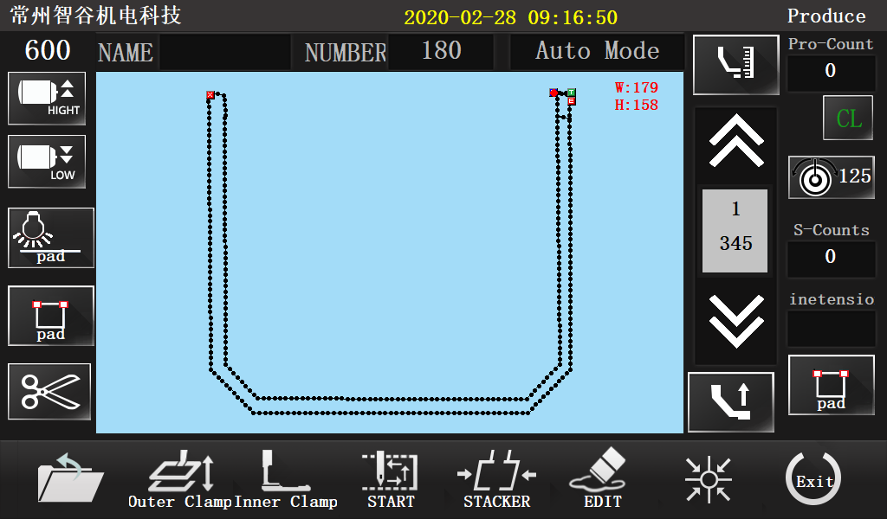

4.2. RESET OPERATION INSTRUCTIONS
4.2.1 POWER ON RESET OPERATION—see 4.1
step |  | Key press
1 | Power on | （1）
2 | reset | （6）--a
3 | Switch sewing mode | （6）--a--b

4.2.2 EMERGENCY STOP RESET OPERATION
Case 1: Emergency stop of the folding group, resetting steps: Turn the emergency stop switch clockwise to reset, the fabric is repositioned, and after the placement is completed, press the start switch (3).
Case 2: Sewing emergency stop, resetting steps: Turn the emergency stop switch clockwise to reset,
（1）Continue sewing：（6）--b--back to sewing point--continue sewing；
（2）Re-sew：（6）--b--reset。

5、OPERATING INSTRUCTIONS
5.1. PREPARATION BEFORE OPERATION
√ The machine head shall be in the stop state when the operator checks it
√ Check whether the pressing plate sponge is intact
√ Check whether the sewing thread has been put on correctly
√ Check whether the needle has been installed
√ Clean the sundries on the machine table to ensure that there are no sundries hindering the operation of the machine
√ Check the pressure of the air pressure gauge to make it meet the use requirements of the machine
√ Check whether the eye guard has been installed correctly

5.2. OPERATION PROCESS DESCRIPTION
5.2.1 BOOT DEVICE
Turn the power switch 90 ° to the on position, and the equipment is powered on.
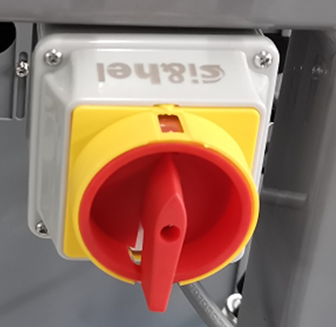

5.2.2 RESET OPERATION
Perform the machine power on reset operation. Please refer to: 1. Key function description -- 2.1 power on reset operation. The following figure shows the status of the device after the reset.
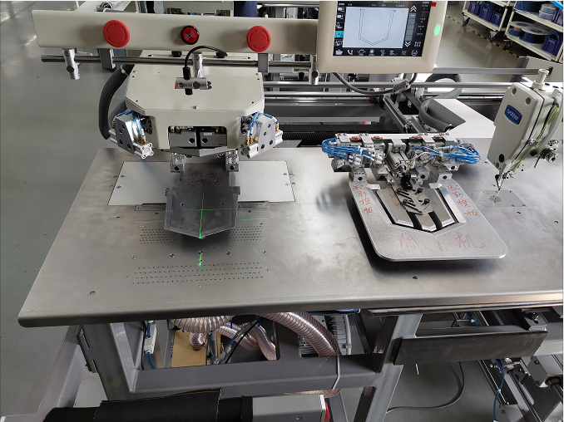
Center blade
* NOTICE：
A:Pedal mode
If the center blade is retracted, the machine is in pedal mode. At this time, step on the pedal continuously, extend the center blade, and open the air suction
B:Automatic mode
If the center blade is extended, suction is on. The machine is in automatic mode

5.2.3 FABRIC PLACEMENT
Place the fabric in the air suction area and align them accurately according to the laser spotlight.
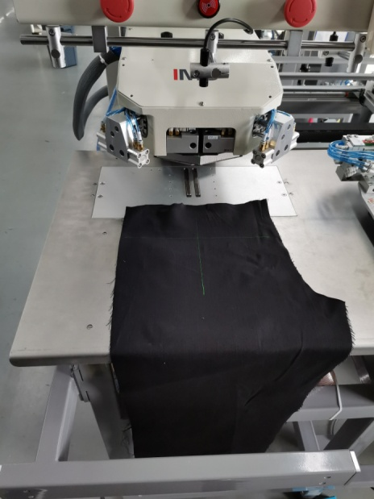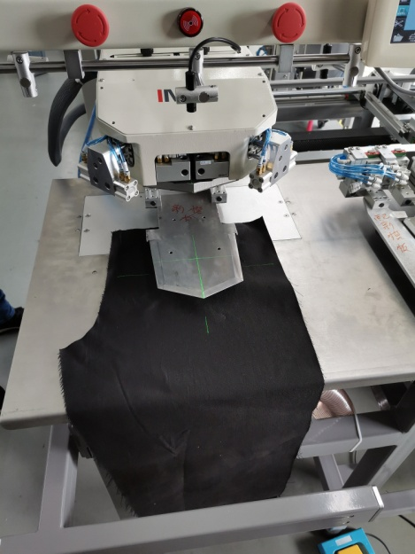
Pedal mode Automatic mode

5.2.4 POCKET PLACEMENT
Pedal mode
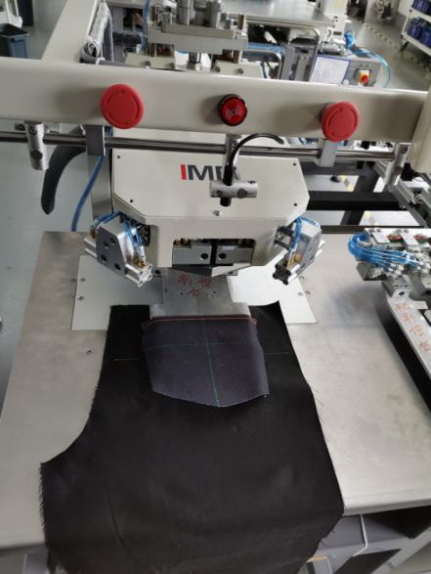
As shown on the right

As shown on the right
Auto mode
Suction on
Center blade extend
Press pedal
5.2.5 AUTOMATIC FOLDING AND SEWING
Press the start switch on both sides, at this time: the folding group extends and descends, the automatic folding is completed, the expansion pressing plate moves to the left to connect the material, the center balde retracts, the expansion pressing plate moves to the right to automatically sew, and the sewing is completed to automatically receive the fabric.
* Move the expansion pressing plate to the sewing area to the right, and then place the fabric, and operate in circle.

5.2.6 SHUTDOWN
After operation, turn the power switch 90 ° to the off position, and the equipment will be shut down

6、CHANGEOVER OPERATION
6.1. JIG REPLACEMENT
6.1.1 JIG POSITION
Right clamp
mould

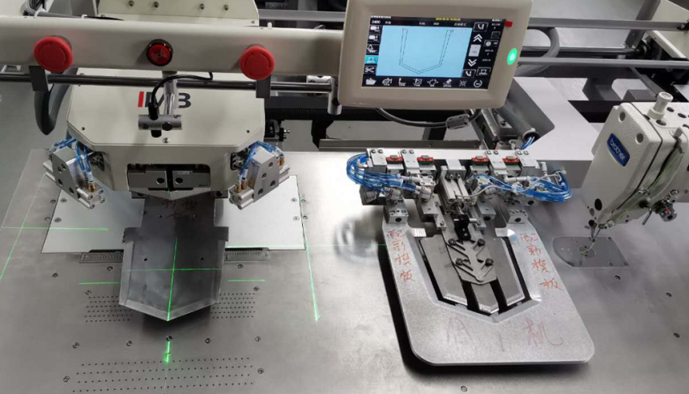
Outer clamp
Inner clamp
Left clamp
Front clamp
Center blade

6.1.2 JIG CHANGING PROCEDURE
6.1.2.1 INTERFACE OPERATION: touch screen (6)-- Main interface (a)-- Then go to the following interface: 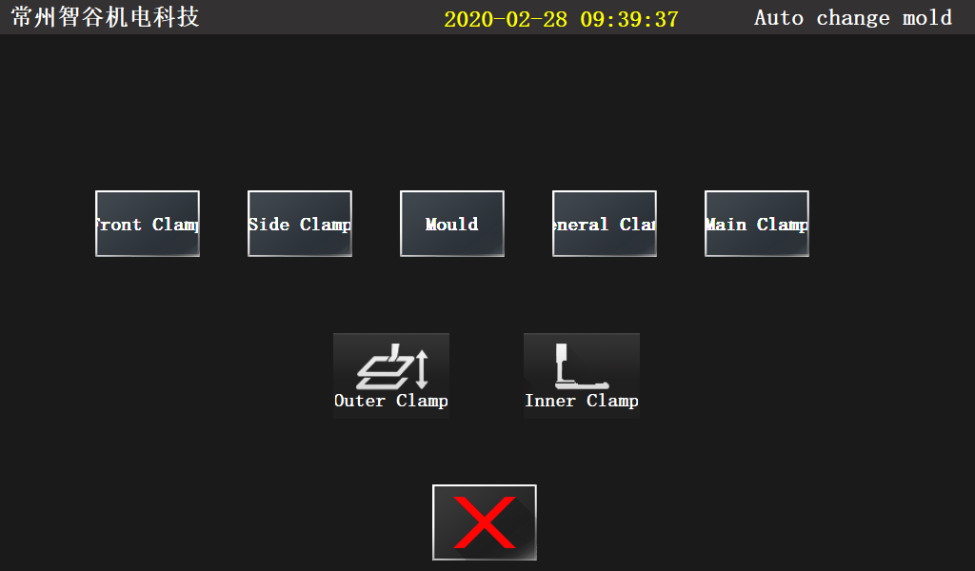

6.1.2.2 DISMANTLING JIG
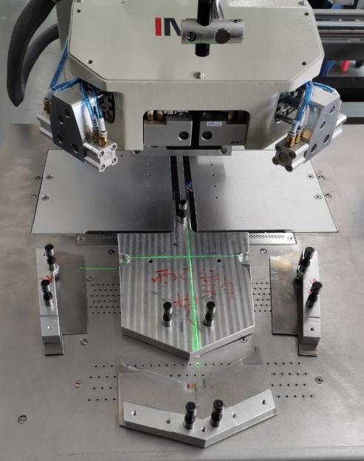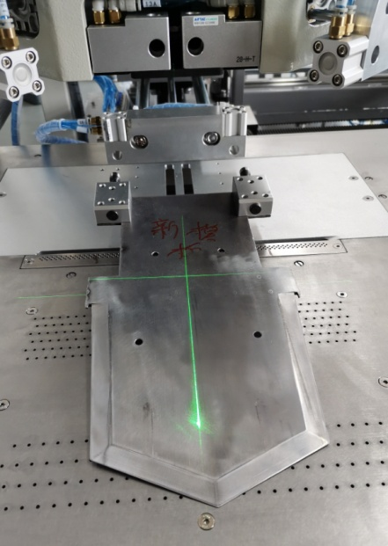
Front clamp
Center blade
Right clamp
Mould
Left clamp
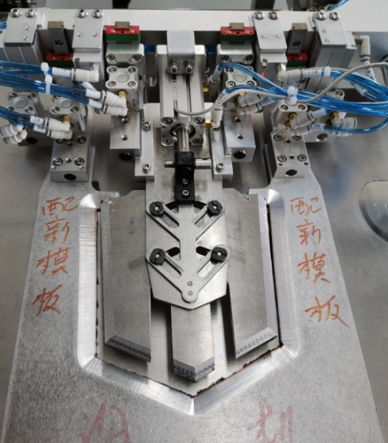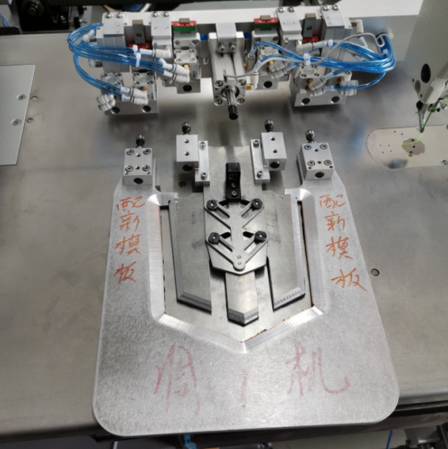
OUTER CLAMP
INNER CLAMP
PIN
* Removal and installation of the folding group shall be carried out according to the steps：1.remove the front clamp--2.remove the left &right clamp--3.remove the mould. The installation sequence is the reverse of the removal sequence。
* Remove the pin before removing the inner clamp.

6.1.2.3 ADJUST THE POSITION OF CORNER PICKS
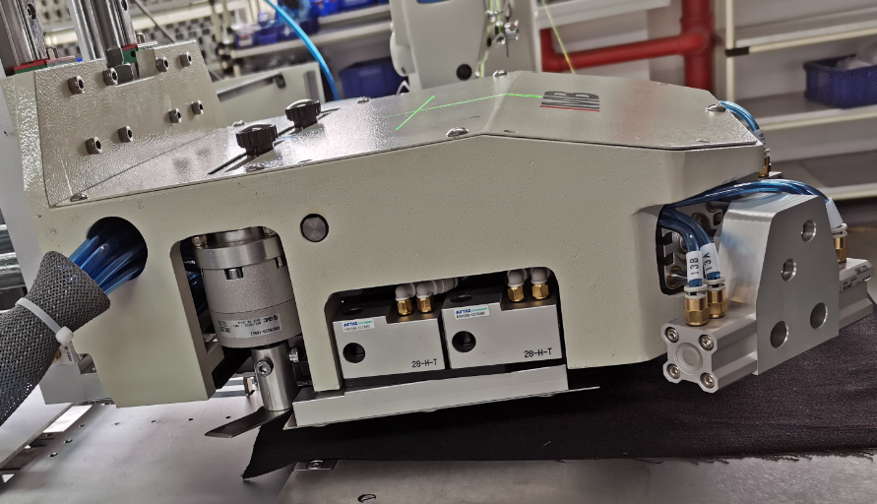
Corner pick
Corner pick-tightening knob
Loosen the corner pick tightening knob, adjust the corner pick position to the right and left, and tighten the knob
6.1.2.4 FEEDING TEST：touch screen（6）--Main a-- --  Then to the following interface：
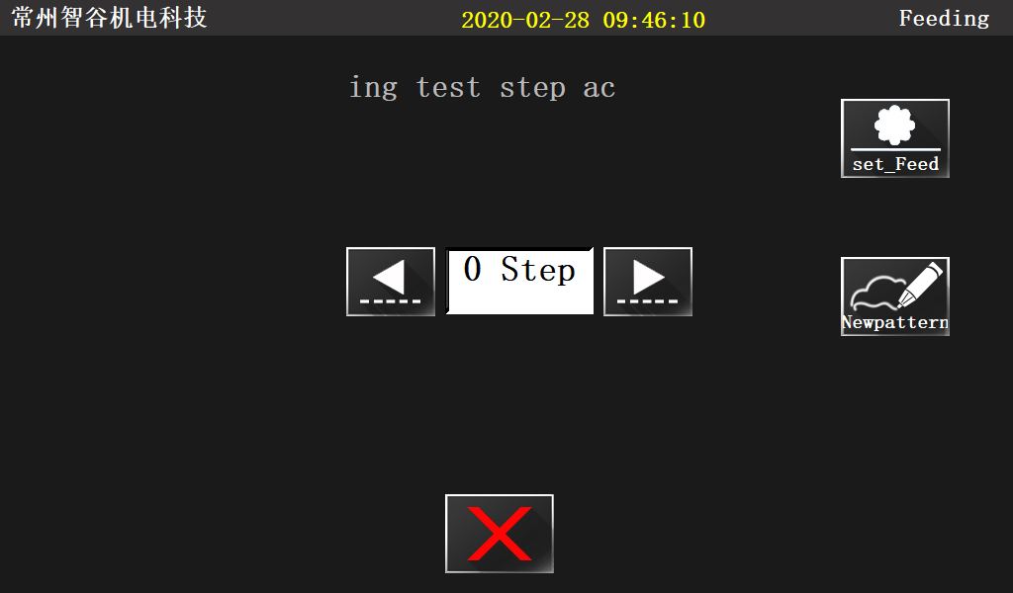
New pattern
forward
backward
Set feed
Steps
Press "Forward" and "Backward" to check the position of the mould and the effect of folding
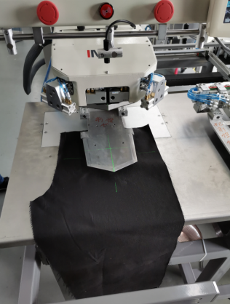 ... 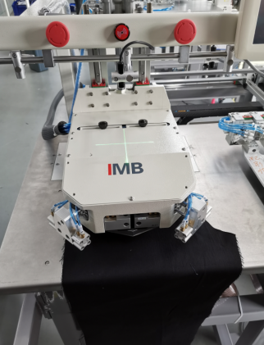 ... 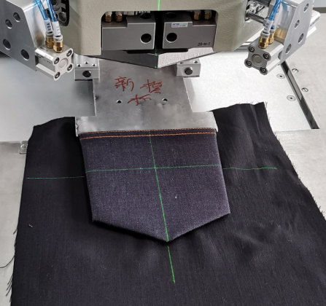
1 Step ... 3 Step ... 16 Step ...
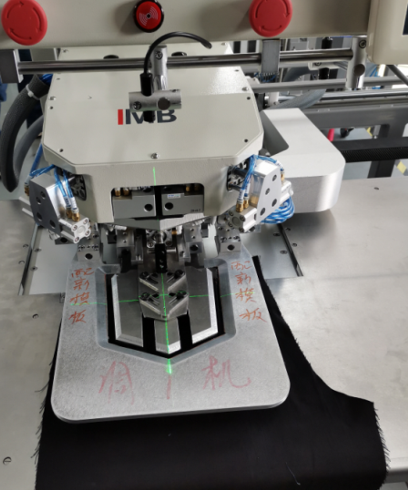 ... 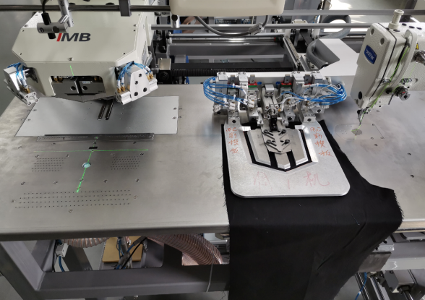
Make a New pattern
18 Step ... 22 Step

NOTE:
*18 Step：Press“set feed”，adjust the upper and lower left and right positions of the inner & outer plate to align with the pocket.
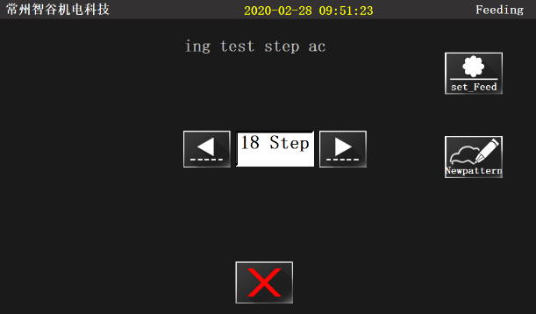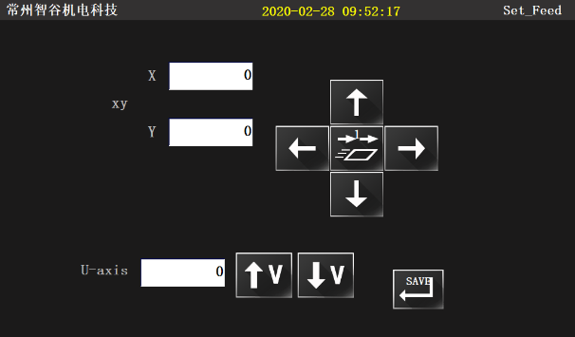
*22 Step：Make a new pattern，For details, please refer to <mb1002f full automatic denim pocket setter touch screen interface operation instructions>
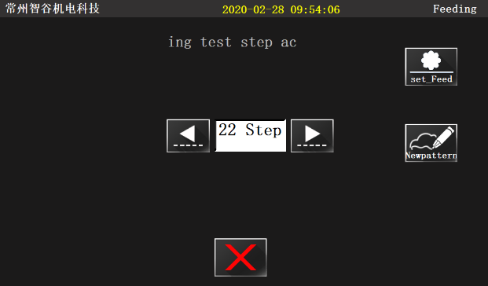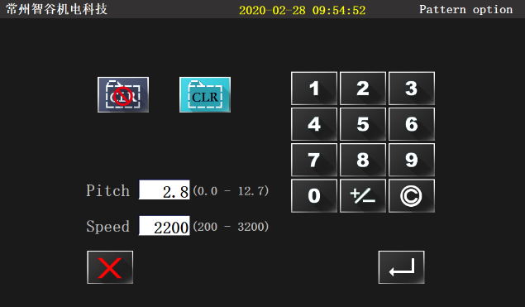

6.2. FULLNESS ADJUSTMENT
6.2.1 FULLNESS DEMONSTRATION
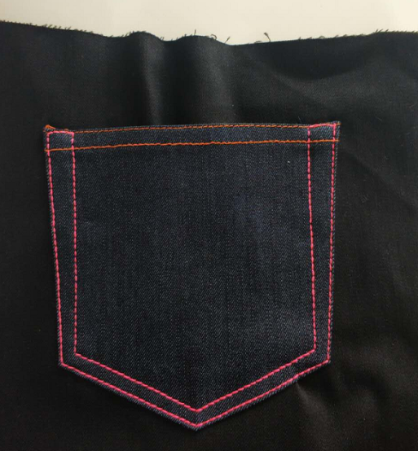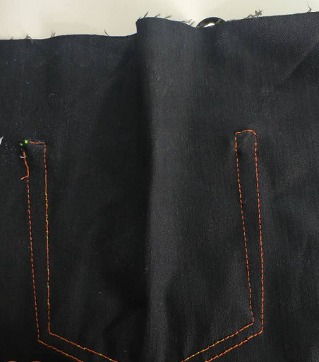

6.2.2 FULLNESS ADJUSTMENT：Manually adjust the extension height of fullness pin
1)fullness adjustment with pad feeding
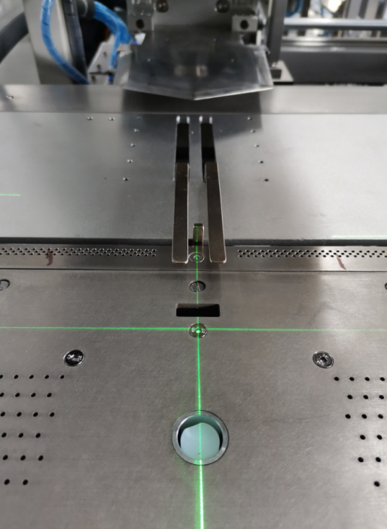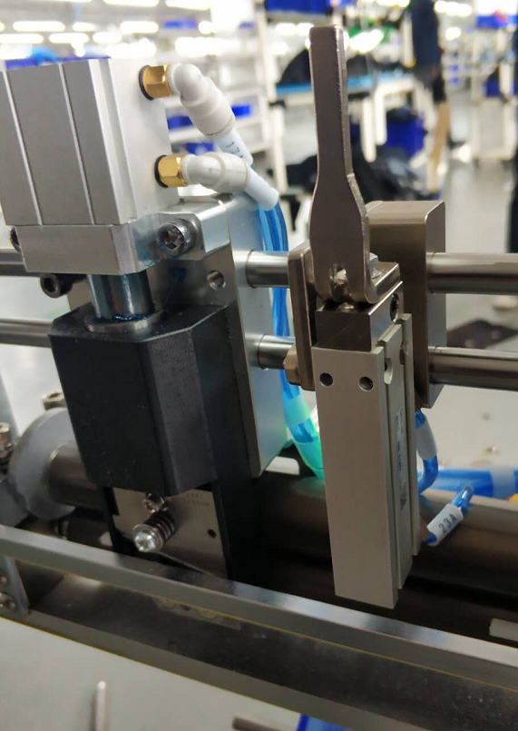
Adjusting screw
Fullness pin

2) fullness adjustment without pad feeding

6.3. PAD FEEDING DEMONSTRATION
6.3.1 PAD FEEDING DEVICE AND DEMONSTRATION
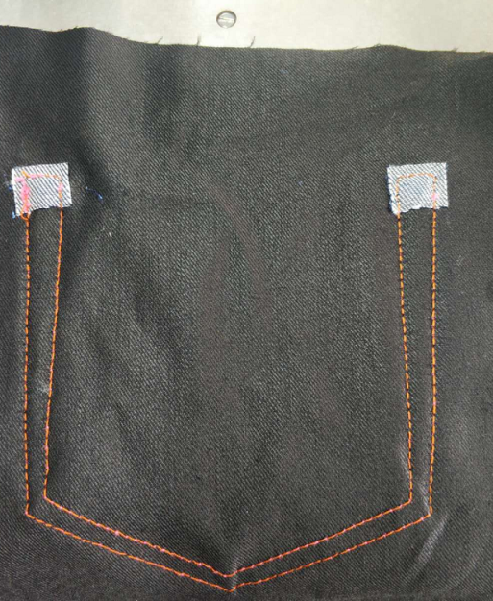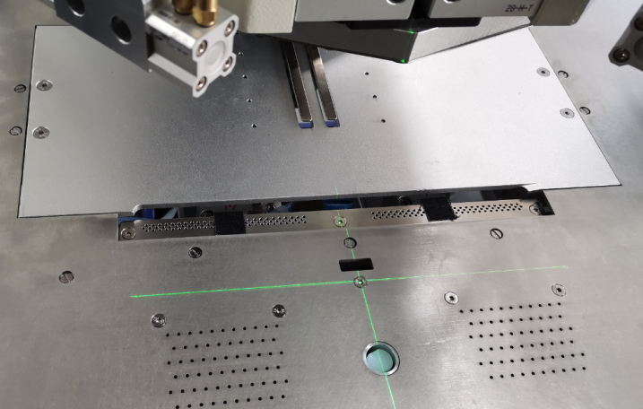
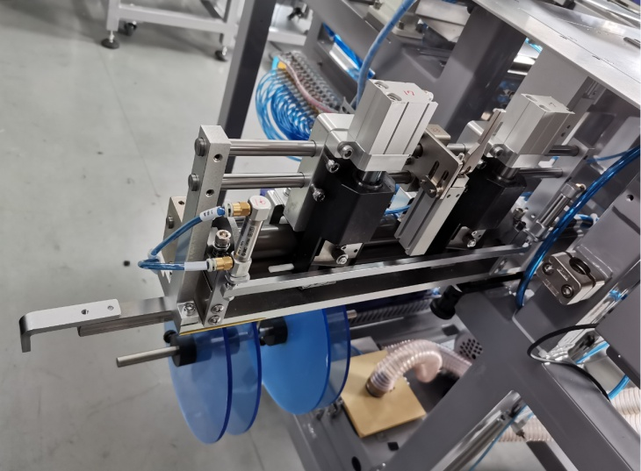

6.3.2 PAD FEEDING ADJUSTMENT
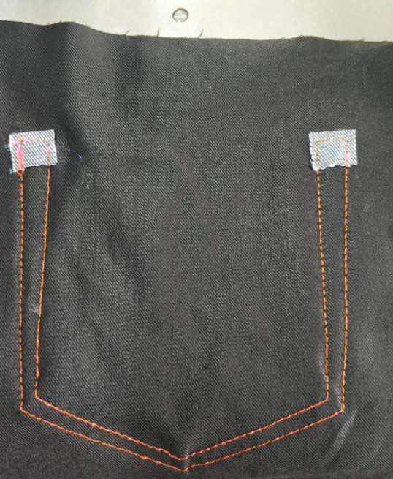
B
A
A Adjustment method：
Suction box
1：As shown in the figure below, loosen the fastening screw and adjust the position of the suction box
Fastening screw
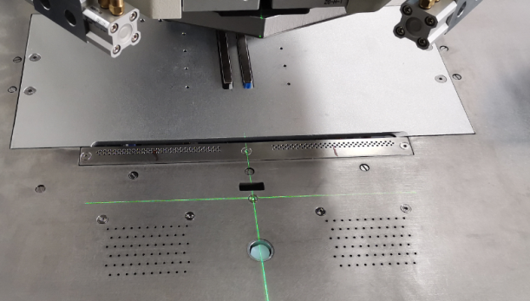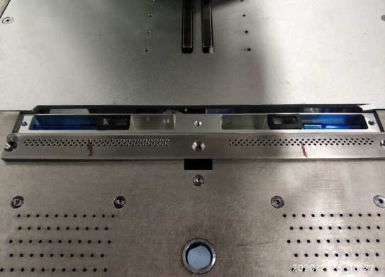
2：As shown in the figure below, loosen the fastening screw and adjust the cutter seat position
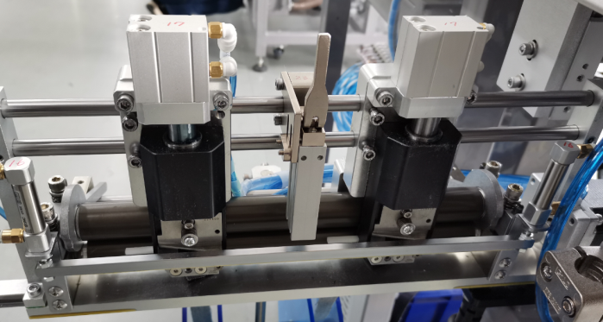
Fastening screw

3：As shown in the figure below, Loosen the hand screw and adjust the position of the pad
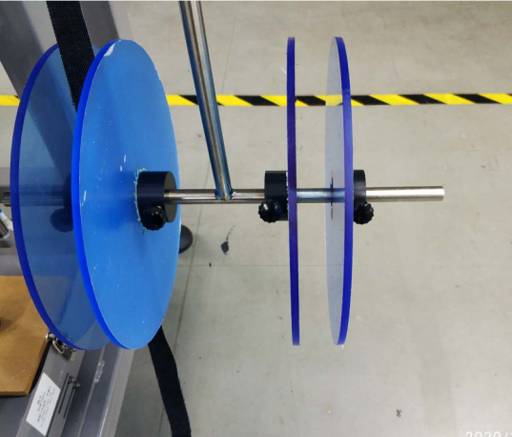
Hand screw
B adjustment method：touch screen（6）--main interface a--  then to the following interface：
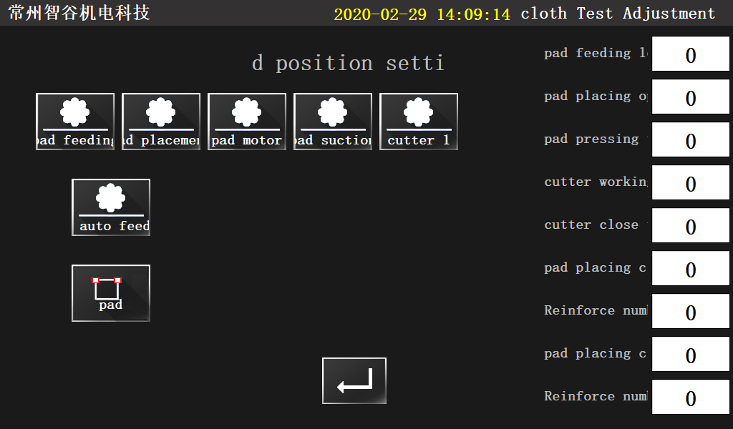
Click "pad feeding 1" on the right side to adjust the value of B.
Parameter adjustment
6.3.3 PAD FEEDING TESTING：touch screen（6）--main interface a
-- then to the following interface：
Pad feeding
Pad switch
Auto feed
*Manually testing： At the beginning, press the operation from left to right; at the exit, press the operation from right to left,

7、ELECTRICAL WIRING
7.1. SIGNAL BOARD：
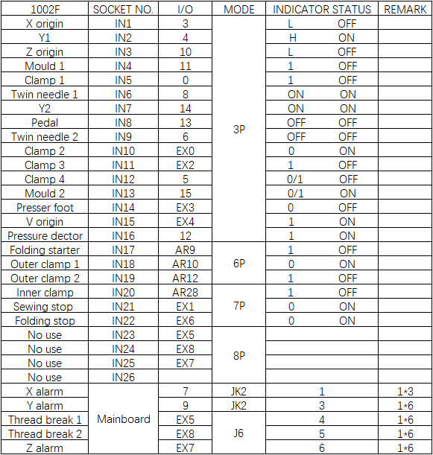

7.2. SOLENOID VALVE BOARD：

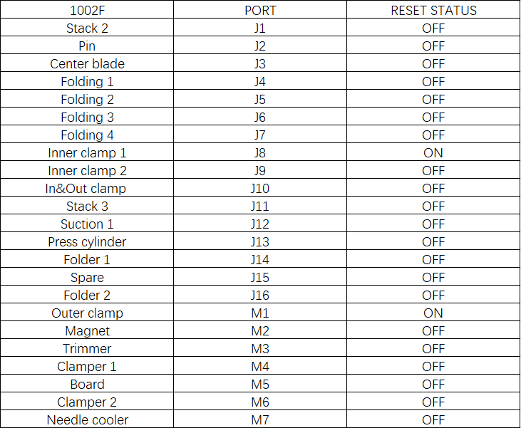

7.3. EXPANSION BOARD ELECTROMAGNETIC VALVE
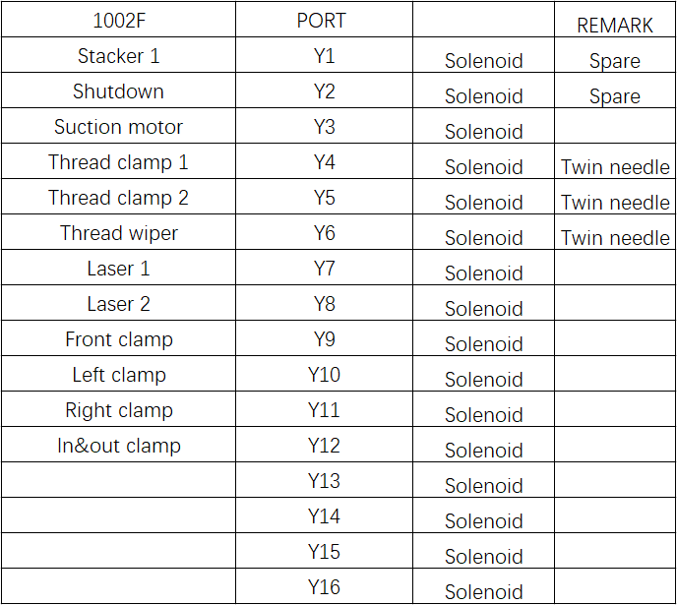

8、OPTIONAL DEVICE
8.1. SIMPLE MOLD: low cost; simple mold making.
For details, please refer to <MB1002F Automatic Jean Pocket setter Machine-Parts Manual>
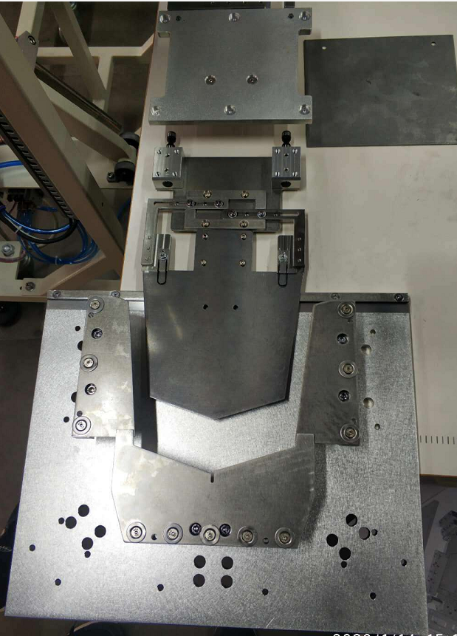

8.2. PAD FEEDING DEVICE：Add padding to reinforce pockets.
For details, please refer to <MB1002F Automatic Jean Pocket setter Machine-Parts Manual>
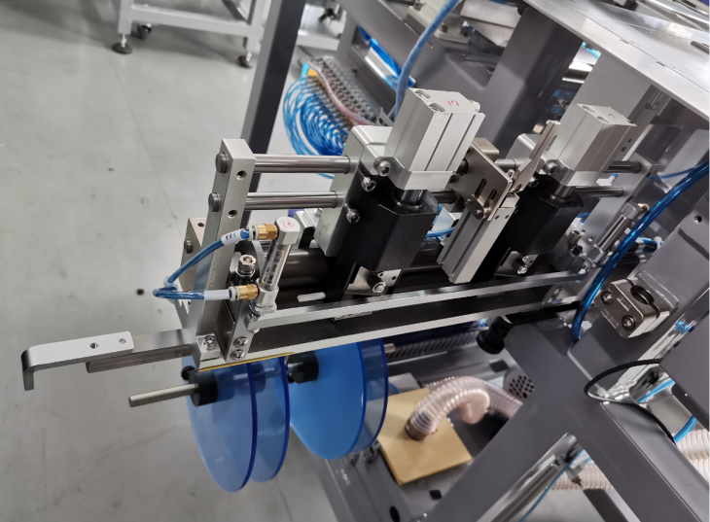

9、ACCESSORIES BOX DETAILS
NO. | ITEM | SIZE | QTY
1 | 《instruction manual》 |  | 1
2 | 《Parts Manual》 |  | 1
3 | 《Touch screen interface operation instructions》 |  | 1
4 | Slotted screwdriver | 5*300mm | 1
5 | Wrench | 1.5--6mm | 1

10、COMMON PROBLEMS AND SOLUTIONS
10.1. SEE THE FOLLOWING TABLE FOR COMMON PROBLEMS AND SOLUTIONS
10.2. FOR MORE QUESTIONS,SEE《MB1002F- Touch screen interface operation instructions》
Fault phenomenon | Image | Cause Analysis | Solutions
Thread break / jumper | / | 1. The height of presser foot is too high；  2.Presser foot touching the clamp； | 1. Adjust the height of presser foot；  2.a. Modified pattern;  b. Modified clamp
Poor edge | 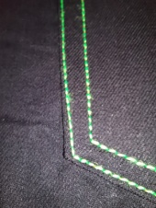 | Pattern issue | 1. Modified pattern
Corner fabric exposure | 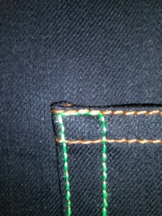 | Corner pick too upward | Adjust the corner pick
Fabric is not folded | 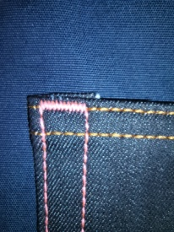 | Corner pick position deviation | Adjust the corner pick position
Pad feeding failure | 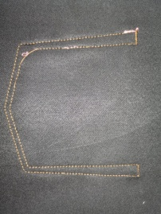 | 1.the roller of pad feeding device is not work；  2. The suction of pad feeding device is not work； | 1.Check the roller；  2.Check the suction box position

11、DAILY MAINTENANCE REQUIREMENTS
11.1. See the following table for the list and requirements of equipment maintenance
11.2. Please refer to brother-bas-311hn for other maintenance requirements
NO. | Item | Frequency |  |  |  | Requirement
 |  | Daily | Weekly | Monthly | Half year
1 | Clean up the dust | √ |  |  |  | Remove dust from equipment surface and parts
2 | Cleaning up oil pollution |  | √ |  |  | Clean the greasy dirt on the table , needle plate and bobbin
3 | Fan filter |  | √ |  |  | Clean the fan filter dust
4 | Clamp sponge |  | √ |  |  | Check whether the sponge is worn and deformed and needs to be replaced if damaged
5 | Folding group |  |  | √ |  | Keep level and check screw tightening
6 | Center blade |  |  | √ |  | Keep level and check screw tightening
7 | Inner&outer clamp |  |  | √ |  | Keep level and check screw tightening
8 | Air tube interface |  |  | √ |  | The air tube interface is tight without air leakage
9 | Oil |  |  | √ |  | Oil volume not lower than warning line
10 | Bobbin |  |  | √ |  | Check if the bobbin is scratched
11 | Eye protector |  |  | √ |  | Check fastening of screws
12 | Sensor |  |  |  | √ | Check if the sensitivity is accurate and if the position changes
13 | Slider |  |  |  | √ | Check slide lubrication and add lubricant if necessary
14 | Electric control box |  |  |  | √ | Cooling fan runs normally, clean up the dust in time

12、KNOWLEDGE PRODUCT PROTECTION STATEMENT
MB1002F denim pocket setter was designed by Changzhou wisdom & valley Electric Technology Co., Ltd.。The intellectual property rights of this achievement belong to Changzhou wisdom & valley Electric Technology Co., Ltd. and are protected by national intellectual property laws and regulations. Without the written permission of the right holder, the patented technology of the achievement shall not be implemented, and the information related to the achievement shall not be copied, sold or disseminated through the network. For any illegal infringement, Changzhou wisdom & valley Electric Technology Co., Ltd. will pursue its legal responsibility according to law.

